SCH3U Learning Portfolio Assignment

Portfolio Evaluation:
Unit work will be collected in TWO portfolio submissions during the course, receiving an overall mark for work included in each and an evaluation of course expectations that are demonstrated at or above standard.
In order to facilitate and encourage improving your understanding, you have the opportunity to improve upon items you submitted in Portfolio 1, if the item meets the following:
- IF YOU RECEIVED LESS THAN LEVEL 3 on the item
- If Portfolio 2, with improved items, is submitted by the Portfolio 2 deadline,
- It is submitted according to instructions in Portfolio :
  - Improved items: Your original work must be copied into the next portfolio, along with the evaluation checklist of the portfolio, with the original work and new work clearly identified.
Please refer to the course Late Policy for any items not completed by the relevant portfolio due date.
- Our Learning and Assessment Cycle for each portfolio item is outlined here
- Due Dates for each Submission will be provided on Unit Plan/Google Classroom
- Submission 1 Artifacts Chart -> List now complete for Spring 2025
- Submission 2 Artifacts Chart -> List now complete for Spring 2025
Click here for one Exemplar Slide for inserting artifacts
Exemplar Portfolio Written work
- Check these to improve your artifact submissions WHEN reflections are required but reflections are also beneficial to your learning even when not required.
VERY IMPORTANT
- PLEASE AVOID PLAGIARIZING YOUR CONTENT OR USING CHATGTP/AI. Note that changing a few words using a thesaurus is STILL plagiarism. See this resource and/or this short video to understand forms of plagiarism.
- EVERY image of paperwork must have your name and signature readable on the paper, including group work items.
- IF ANY PART OF YOUR WORK IN ONE PORTFOLIO SUBMISSION IS PLAGIARIZED OR COPIED FROM GOOGLE/CHATGPT/AI you will need to redo the entire portfolio submission (eg ALL items and written extensions etc) handwritten and in person during your lunch within one week of being notified.

Required Learning Artifacts for Submission 1
(list is complete when indicated! Otherwise, it is a live document and I will add as we go):
NOTES:
- Any work that you can put in as a readable image, so I don’t have a separate link to open is appreciated :)
- If you have either submitted it on Classroom OR I have assigned a document to you , it is already shared with me. If you copy in the url link to your portfolio slides I can access it. Do this only for larger documents!
- Otherwise, ensure all links are shared with me.
- Organize so all items are in the order in the tables below and so written work for artifacts are either on the same slide or slide AFTER, not before the related artifact.

Artifact | Level 3 Artifact Description | SCH3U Extend (Level 4) | Curriculum Expectation
Aluminum lab 3-2-1 | → Copy in your slide after improving it based on feedback given in class.  → Explain at least two improvements that could be made to your method to get a more accurate value for the thickness. | Explain the importance of measurement in science & why using significant figures is essential (consider what would change about results reported if significant figures were not utilized in science). What else did you learn from this? | Investigate and communicate physical and chemical properties of elements
Periodic Trends Activity (larger value) | → Include the full ACTIVITY, with both graphs and the questions on the ACTIVITY sheet answered. Point form is fine,  Answers should be 1-3 sentences MAX per question.  → Do NOT include the Questions sheet. | → Explain how the ionization energy trend is determined largely by the atomic radius trend.  → How does atomic radii help in understanding why metals lose electrons while nonmetals gain electrons in forming ionic compounds | Understand the trends in periodic table (3U)
Bonding Unit
Full Nomenclature Quia Quiz | Follow instructions on classroom post.  Include your result and an explanation of at least two of your answers, use two you had incorrect on your first attempt. If you didn’t have two incorrect, explain why your answers were correct.  You Do NOT need to include the Active recall question answers. | Include one example of naming an acid and one example of determining an acid formula from its name with a BRIEF description of the rules used to determine the answer. At least ONE acid should be polyatomic. | Investigate and communicate physical and chemical properties of compounds and reactions
Building Molecules Sheet | Include your work as submitted on Classroom & briefly reflect on any class feedback provided. | Explain at least 3 factors that must be considered in determining the shape AND polarity of a molecule. Eg How do unbonded electron pairs affect shape? How do polar vs non-polar bonds affect shape? | Investigate and communicate physical and chemical properties of compounds and reactions
Your choice Extension Artifact | ADD ONE OF THESE OPTIONS  Needs to be good quality and show application or novel processing of course content (course notes do NOT count).  - One Sketchnote that must have good coverage of at least one unit topic, such as Bohr atom model [How to sketchnote]  - Evidence of spaced and/or retrieval practice (eg a series of brain dumps over time, attempts at a variety of quizzes not in list above, spread out over time, etc)  - Create an Anki deck with a minimum of 15 cards ( and share it with me for future students :) ). Example of AnkiWeb. Many more options on App version of Anki.  - Make a Quiz with Answers,  - include your name as the author in the quiz  - 3-4 MC questions with 4 answer choices each. You must include FEEDBACK for each answer choice to help a peer improve & understand why the right answer is correct  - 1-2 short answer questions with answer and feedback  - Please include a link directly to your quiz in your portfolio. I need to be able to access it to mark it  - AND include it in SCH3U Exam Practice Quizzes & Tools {Screen shot the slide you added to into your portfolio as proof}. |  | Various
CHECKLIST | After you have read full instructions above, you may find the checklist below helpful to ensure you include everything

Required Learning Artifacts for Submission 2

Artifact | Level 3 Artifact Description | SCH3U Extend (Level 4) | Curriculum Expectation
Bonding Unit
Household Products Activity  Must have partner’s names indicated in portfolio | Insert insert a LINK (NOT images due to it being partner work) to original document with your and your partner’s names on it. Include your work as submitted on Classroom & reflect on what you learned & any class feedback provided. | Extension built into activity by completing a full and well reasoned justification for your product choice. | Analyze chemical reactions (uses/impacts/environment)
Stoichiometry Artifacts
Limiting Lab Questions  Must have partner’s names indicated in portfolio/written on physical work | Include your lab artifact with questions fully answered .  Describe how doing the “live” limiting lab impacted your understanding of the concept. | Explain why in a “real world” reaction you will always have a limiting and excess reactant (you will never do a reaction where the reactants all fully react).  Briefly explain at least two factors that should be considered in deciding which reactant to have in excess? | Investigate and communicate quantitative relationships in chemical reactions
Solubility Unit
Double Displacement & Solubility Table Quia Quiz | Include your result and an explanation of at least two of your answers, use two you had incorrect on your first attempt. If you didn’t have two incorrect, explain why your answers were correct. | Explain the difference between using the activity series and using the solubility table. | Communicate qualitative and quantitative properties of solutions
Solubility Curves Lab | Complete in partners and include with partner’s name shown in photo(s). Submit your completed lab, with graph and all analysis questions. INCLUDE a photo of your original data. There likely won’t be any class feedback in advance of submission given the timeline. | Briefly research and describe in a paragraph, one practical application of understanding solubility curves (eg medicine, industry). | Investigate qualitative and quantitative properties of solutions
{OPTIONAL} Test Reflection on ONE prior test | Use the Test Class FeedbackSheet (If provided for that test) posted on Classroom and your marked test and class notes/learning materials. Follow the Next Steps on the Feedback sheet to provide corrected understanding of the test material. Must include an image of the ALL short answer questions with your original test answers. Correct ALL short answer questions that didn’t receive full value. | Acts as a mark boost to this portfolio
Your choice Extension Artifact | Choice must be DIFFERENT than your Portfolio 1 selections but instructions are the same (see above). Portfolio 2 options:  - Mindmaps  - Sketchnotes  - Evidence of spaced and/or retrieval practice (eg a series of brain dumps over time, attempts at a variety of quizzes not in list above, spread out over time, etc, flashcards dated & inserted into portfolio so show creation over time)  - Create an Anki deck with a minimum of 15 cards ( and share it with me for future students :) )  - Find or create a quiz or flashcards (& use them with reflection on your learning/how you did) Add a direct link to the item in the portfolio AND include it in SCH3U Exam Practice Quizzes & Tools {Screen shot the slide you added to for portfolio}
CHECKLIST | After you have read full instructions above, you may find the checklist below helpful to ensure you include everything |  | CHECKLIST

Exemplar Artifact Slide
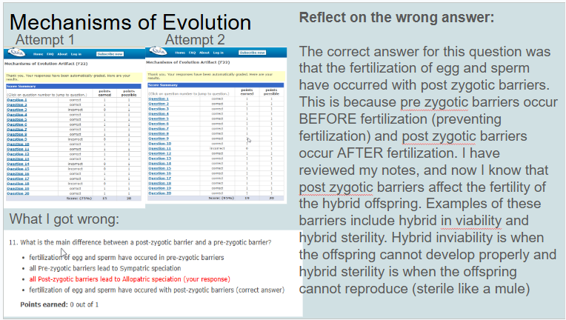

Exemplar written work

Teacher commentary in purple & bold
- This is exactly what the portfolio work should accomplish. The opportunity to understand a topic correctly based on the learning artifact & any mistakes or feedback, and then and practice that understanding in the written answers.
- During my first time taking this quiz, I noticed that I was particularly having trouble with chemical reactions that had more than one of a given element or polyatomic ion.
  - First Error: “NaOH + H₂CO₃ →”
  - I answered with “NaCO₃ + H₂O” because I thought that the H₂ had no effect on the CO₃ so I just switched the H and the Na around (since it’s a double replacement reaction) without paying attention to the ionic charge of carbonate (2-). The product I was thinking of was “NaCO₃ + H₃O”. But I know now that I have to have two sodium atoms to go along with the carbonate polyatomic ion because of its ionic charge (2-).
  - Correct Answer: Na₂CO₃ + H₂O
- This is a great example of how to reflect if the item is perfect. Shows their knowledge of an aspect of the artifact and the written reflection provides another type of practice for you to help you retain it long term!
- I got a 10/10 on this quia quiz. One thing that I furthered my learning on was that the different numbers of oxygen will result in a different prefix or suffix, or both for the acid. For example, if an acid has one less oxygen than the root it will be the root followed by the suffix ite, but since it's an acid the ending becomes ous. In addition I know that the number of hydrogens is equal to the charge of the anion.
- An interesting way to present your learning:
- 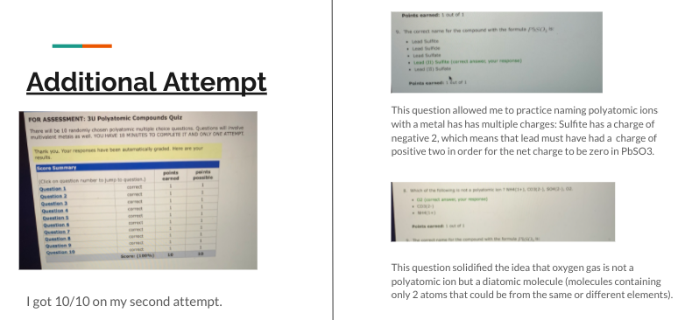
  - This is good, showing specific understanding clearly and ideas for improvement -> Reflection: Important things to remember when naming
  - Ionic compounds end in “ide”
  - Covalent compounds require prefixes to show the number of each element
  - Etc {Your additions}
  - Further improvement:
    - I can do these accurately, but things I can work on include:
      - {Your ideas}
      - etc

- Also, good with some specific details and indicated what was learned in doing this. Recalling back to grade 10 and learning to draw Bohr Rutherford diagrams helped when we had to draw these on the first day although I now know the extra steps to take to make it even more precise.
I learned that all the outer rings should be dashed lines except for the one around the nucleus and that every row you move down on the periodic table you then add another orbital. Bohr Rutherford diagrams show the electrons orbiting the nucleus of an atom for specific elements.
- On this polyatomic compounds quiz I received a 9/10. I was originally confused by question 9 because I forgot to add the subscripts when figuring out what the formula for Calcium Phosphate was. I now know that you have to figure out what subscript number belongs to each element and cross them over which then will reveal the correct formula for for each polyatomic compound. Another example to show was I have learned is : (This had an image demonstrating how to do this… an excellent way to show improvement and understanding in the reflection!)
- I learned the reason we use significant figures is because they help to show the accuracy of an answer, and the more significant figures a value has, the more accurate the answer will be since the percentage error is less. I also learned that the certain and the last uncertain digit in a measurement will be significant figures. For example, even if the volume of a liquid is 25.0 mL, and the 0 is an uncertain digit, that zero is still a significant figure and must be recorded. The original reflection continued to make specific points to demonstrate knowledge, but this gives you a good idea of how to do that.
- My first attempt of this quiz I got 16/19. I overall understood most questions but my mistakes consisted of questions like, figuring out which pairs would react the fastest in a replacement reaction, figuring out which compound was produced, and figuring out what X would be. I reviewed my mistakes after trying the first time and my second attempt of the quiz I got 19/19. After doing it the second time I feel very confident with Single Displacement & Double Displacement reactions using the activity series. This is a start but is a level 1 - 2 because is does not “Show what they know”. You can’t answer a test questions with “I know understand this” and get marks, this is similar.

SCH3U Learning Portfolio Checklists

GENERAL CHECKLIST EACH PORTFOLIO
- Include your name/signature on all physical work before inserting as a photo
- Include partner’s name also physically written on items as needed, or digital if only digital work
- Make all images and text large enough to read easily (err on the larger is better side)
- Put each artifact in the order they are listed in tables and put level 3 work for each item before the extend work for each item

Submission 1 Checklist

Aluminum Lab 3-2-1
- Include improved slide based on class feedback
Extension (Level 4):
- Explain importance of measurement in science
- Explain why significant figures are essential
- Describe what would change if significant figures weren't used
- Include additional learnings from this lab

Periodic Trends Activity
- Include full activity with both graphs, following all instructions
- Answer all activity sheet questions (1-3 sentences max per question)
- Do NOT include questions sheet
- Check feedback and correct/improve as needed.
Extension (Level 4):
- Explain how ionization energy trend relates to atomic radius trend
- Describe how atomic radii help explain why metals lose electrons and nonmetals gain electrons

Bonding Unit

Nomenclature Quiz
- Include quiz result
- Explain two incorrect answers (or why answers were correct if perfect score)
Extension (Level 4):
- Include one example of naming an acid
- Include one example of determining acid formula from name
- At least one acid example must be polyatomic
- Briefly describe rules used

Building Molecules Sheet
- Include submitted work
- Reflect on class feedback
Extension (Level 4):
Explain 3 factors affecting molecular shape AND polarity:
- How unbonded electron pairs affect shape
- How polar vs non-polar bonds affect shape
- One additional factor

Your Choice Extension Artifact
Select ONE option:
- Sketchnote with good coverage of unit topic
- Evidence of spaced/retrieval practice
- Anki deck (shared with teacher)
- Quiz with:
  - 3-4 MC questions with feedback for each choice
  - 1-2 short answer questions with answers & feedback
  - Your name as author
  - Screenshot showing inclusion on class test review slidesL SCH3U Exam Practice Quizzes & Tools
  - Accessible link included in portfolio

Submission 2 Checklist

Bonding Unit

Household Products Activity
- Include LINK (not images) to original document
- Ensure partner names are indicated
- Reflect on learning and class feedback
Extension (Level 4):
- Complete full, well-reasoned justification for product choice

Stoichiometry Artifacts

Limiting Lab Questions
- Include lab artifact with fully answered questions
- Describe how "live" lab impacted understanding
- Ensure partner names are indicated
Extension (Level 4):
- Explain why real-world reactions always have limiting/excess reactants
- Describe two factors in deciding which reactant to have in excess

Solubility Unit

- Double Displacement & Solubility Table Quiz
- Include quiz result
- Explain two incorrect answers (or why answers were correct if perfect score)
Extension (Level 4):
- Explain difference between activity series and solubility table usage

Titration Virtual Activity
- Submit completed Virtual Titration sheet (link or readable image)
- Reflect on understanding of titration
- Explain how stoichiometry learning applies
Extension (Level 4):
- Research and describe one practical application of titration

Optional Test Reflection
- Use Test Class Feedback Sheet
- Include image of ALL short answer questions with original answers
- Correct ALL short answer questions that didn't receive full value

Your Choice Extension Artifact
Select ONE DIFFERENT option from Portfolio 1:
- Mindmaps
- Sketchnotes
- Evidence of spaced/retrieval practice
- Anki deck (shared with teacher)
- Quiz with:
  - 3-4 MC questions with feedback for each choice
  - 1-2 short answer questions with answers & feedback
  - Your name as author
  - Screenshot showing inclusion on class test review slides: SCH3U Exam Practice Quizzes & Tools
- Accessible link included in portfolio

